FinAgent
Investment Analysis Report
AI-Powered Financial Data Pipeline

Assets Analysed: AAPL | MSFT | NVDA | GOOGL
Generated: 2026-05-06 10:52
AI Provider: Groq — llama-3.3-70b-versatile
Data Source: Yahoo Finance (yfinance)

This report is generated for academic purposes only and does not constitute financial advice. All analysis is based on historical data.

Asset Summary Statistics
Key price and risk metrics for all tracked assets over the past 12 months.
Ticker | Company | Price | 52w High | 52w Low | Period Ret | Ann. Vol | Sharpe | Trend
AAPL | Apple Inc. | $284.18 | $285.92 | $194.68 | +43.78% | 23.31% | 1.69 | ↑ Above MA30
MSFT | Microsoft Corporation | $411.38 | $539.83 | $356.77 | -4.33% | 23.60% | -0.07 | ↑ Above MA30
NVDA | NVIDIA Corporation | $196.50 | $216.61 | $113.51 | +73.11% | 33.88% | 1.80 | ↑ Above MA30
GOOGL | Alphabet Inc. | $388.43 | $388.43 | $150.86 | +138.79% | 29.99% | 3.08 | ↑ Above MA30

Data Visualisations
All charts are generated from cleaned historical data. Moving averages and Bollinger Bands use 7-day, 30-day, and 20-day windows respectively.
Chart 1 — Price Trend & Volume
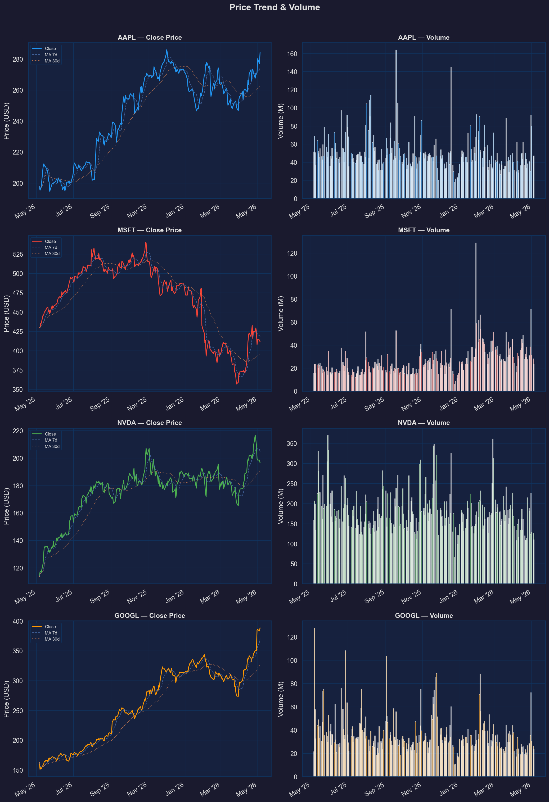
Close price with 7-day and 30-day moving averages alongside daily trading volume.
Chart 2 — Daily Return Correlation Heatmap
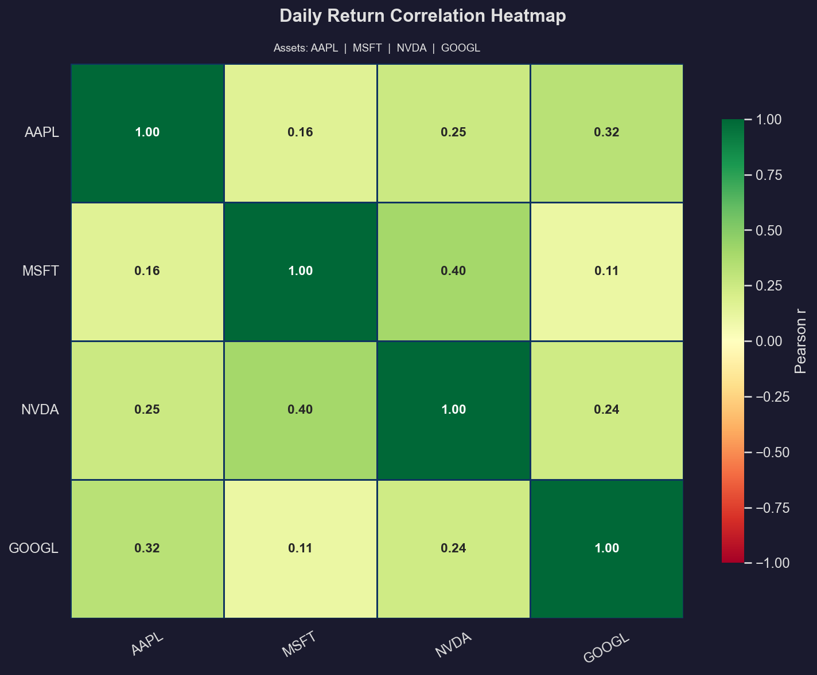
Pearson correlation coefficients between daily returns. Values near +1 indicate assets move together; near 0 indicates independence.
Chart 3 — Return Distribution (Histogram + KDE)
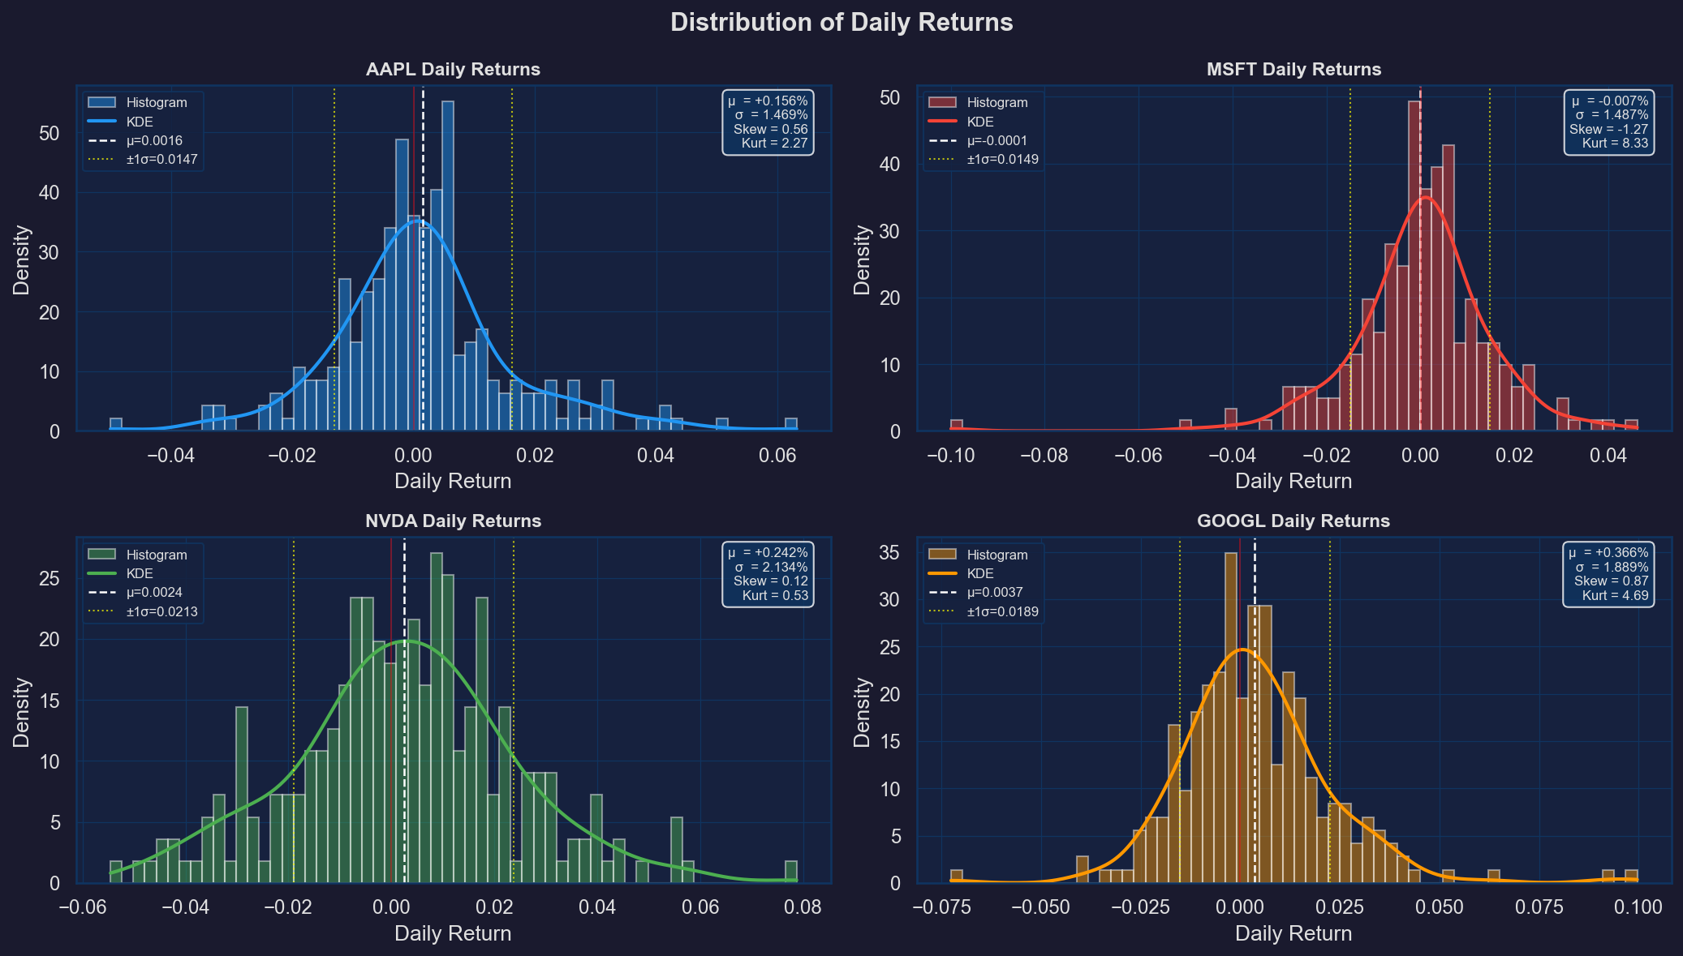
Histogram and KDE of daily returns with mean (dashed) and ±1σ (dotted) markers. Skew and kurtosis values indicate tail risk.
Chart 4 — Rolling Statistics & Bollinger Bands
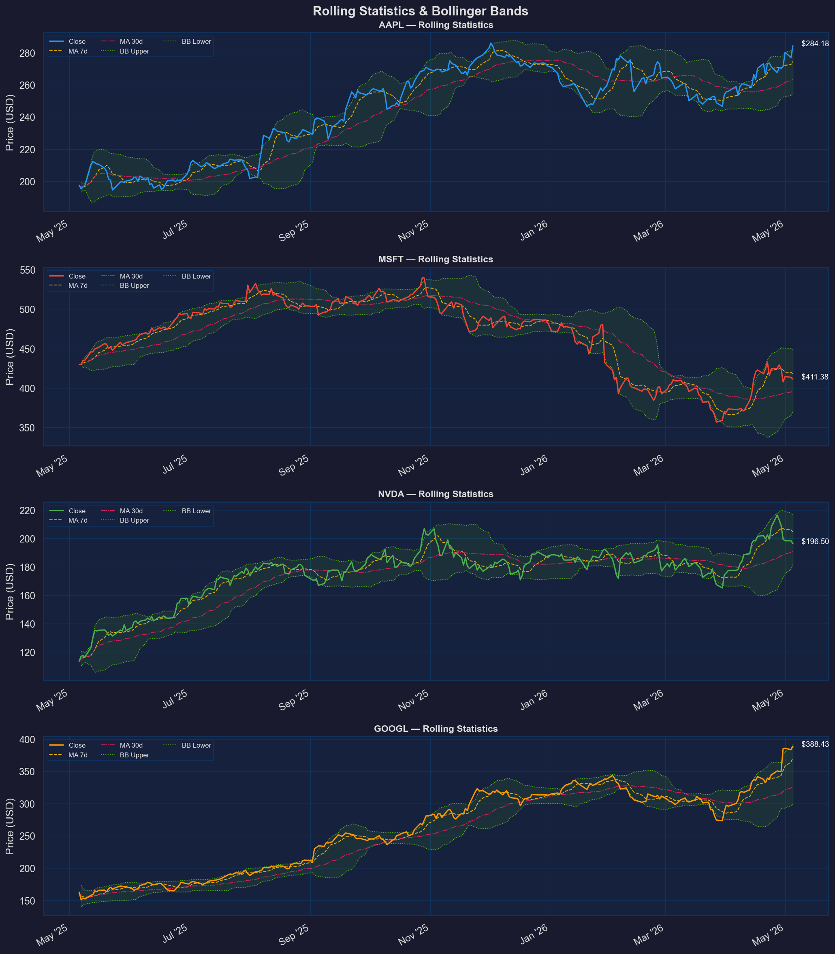
Close price overlaid with MA7, MA30, and Bollinger Bands (20-day, ±2σ). Price touching the upper band may signal overbought conditions.
Chart 5 — Cumulative Returns Comparison (Bonus)
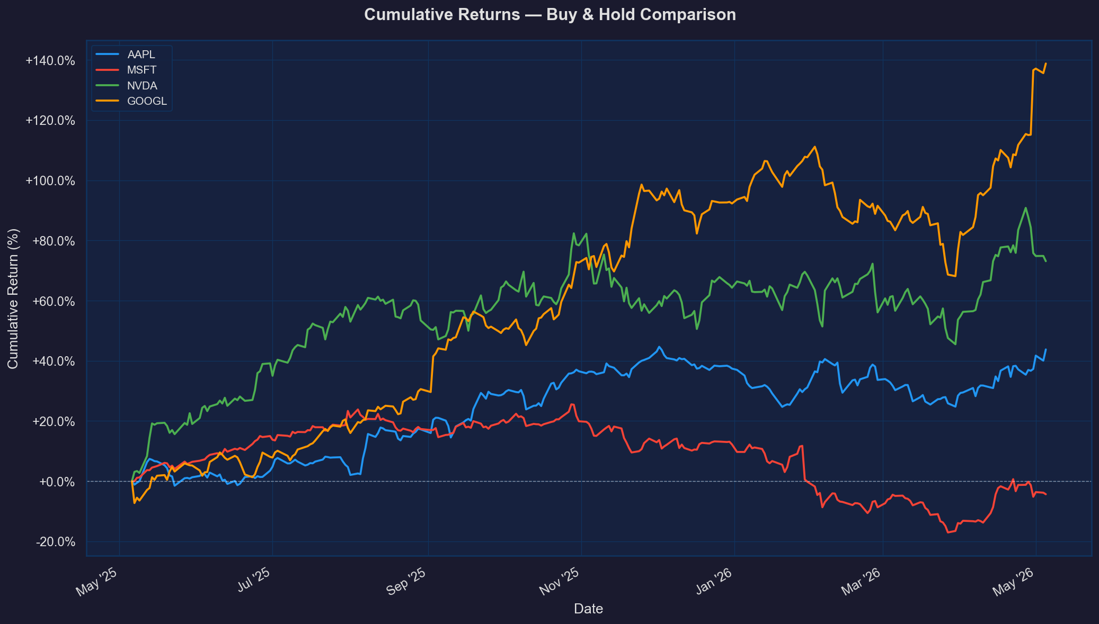
Normalised buy-and-hold cumulative return from the start of the analysis period. Allows direct performance comparison across assets.

1. Stock Stories & Key Drivers
A plain-English narrative of what drove each stock over the analysis period — covering the business story, the price story, and the news catalyst story.

Apple Inc. (AAPL)

The Business Story:
Apple Inc. is a technology company that designs, manufactures, and markets consumer electronics, software, and services. With a market capitalization of $4173.9B, Apple is a dominant player in the technology sector. Its core competitive advantage lies in its brand loyalty, innovative products, and ecosystem. The company is currently benefiting from the growing demand for smartphones, personal computers, and wearables.

The Price Story:
Over the past 12 months, Apple's stock price has increased by 43.78%, with a 52-week high of $285.92 and a 52-week low of $194.68. The current price of $284.18 is above its MA30, indicating a bullish trend. The single most important reason for this price movement is the strong demand for Apple's products, particularly the iPhone, which has driven revenue growth.

The News & Catalyst Story:
Recent news articles have highlighted Apple's potential partnership with Intel to manufacture chips, which could reduce the company's dependence on external suppliers. Additionally, the company's discussions with TSMC to potentially add Intel as a supplementary or alternative supplier have been making headlines. These developments could have a positive impact on Apple's stock price in the near term.

Microsoft Corporation (MSFT)

The Business Story:
Microsoft Corporation is a technology company that develops and supports software, services, devices, and solutions. With a market capitalization of $3055.9B, Microsoft is a leading player in the software industry. Its core competitive advantage lies in its dominant position in the productivity software market, particularly with its Microsoft 365 commercial products. The company is currently facing challenges from the growing competition in the cloud computing market.

The Price Story:
Over the past 12 months, Microsoft's stock price has decreased by 4.33%, with a 52-week high of $539.83 and a 52-week low of $356.77. The current price of $411.38 is above its MA30, indicating a bullish trend. The single most important reason for this price movement is the company's efforts to transition its business model to cloud-based services, which has led to increased investment in research and development.

The News & Catalyst Story:
Recent news articles have highlighted Microsoft's participation in the Terafab initiative, which could drive the company's growth in the AI and cloud computing markets. Additionally, the company's earnings report is expected to be a key catalyst for the stock price in the near term. The news narrative is generally positive, with analysts expecting Microsoft to benefit from the growing demand for cloud-based services.

NVIDIA Corporation (NVDA)

The Business Story:
NVIDIA Corporation is a technology company that operates as a data center scale AI infrastructure company. With a market capitalization of $4775.9B, NVIDIA is a leading player in the semiconductor industry. Its core competitive advantage lies in its dominant position in the graphics processing unit (GPU) market, particularly in the data center and gaming segments. The company is currently benefiting from the growing demand for AI and cloud computing.

The Price Story:
Over the past 12 months, NVIDIA's stock price has increased by 73.11%, with a 52-week high of $216.61 and a 52-week low of $113.51. The current price of $196.50 is above its MA30, indicating a bullish trend. The single most important reason for this price movement is the strong demand for NVIDIA's GPUs, particularly in the data center segment, which has driven revenue growth.

The News & Catalyst Story:
Recent news articles have highlighted NVIDIA's growth in the AI and cloud computing markets, particularly with its data center accelerated computing and networking platforms. Additionally, the company's earnings report is expected to be a key catalyst for the stock price in the near term. The news narrative is generally positive, with analysts expecting NVIDIA to benefit from the growing demand for AI and cloud computing.

Alphabet Inc. (GOOGL)

The Business Story:
Alphabet Inc. is a technology company that offers various products and platforms, including Google Search, Google Cloud, and YouTube. With a market capitalization of $4706.0B, Alphabet is a dominant player in the internet content and information sector. Its core competitive advantage lies in its dominant position in the search engine market, particularly with its Google Search platform. The company is currently facing challenges from the growing competition in the online advertising market.

The Price Story:
Over the past 12 months, Alphabet's stock price has increased by 138.79%, with a 52-week high of $388.43 and a 52-week low of $150.86. The current price of $388.43 is above its MA30, indicating a bullish trend. The single most important reason for this price movement is the strong demand for Alphabet's online advertising services, particularly with its Google Search and YouTube platforms.

The News & Catalyst Story:
Recent news articles have highlighted Alphabet's growth in the cloud computing market, particularly with its Google Cloud platform. Additionally, the company's earnings report is expected to be a key catalyst for the stock price in the near term. The news narrative is generally positive, with analysts expecting Alphabet to benefit from the growing demand for cloud computing and online advertising services.

2. Company Overview
Apple Inc. (AAPL)
Apple Inc. is a technology company that designs, manufactures, and markets consumer electronics, software, and services. The company's core business model is based on the sale of iPhones, Macs, iPads, and wearables, with a strong focus on ecosystem and brand loyalty. Apple is a dominant player in the technology sector, with a market capitalization of $4173.9B. Recent strategic developments include the potential partnership with Intel to manufacture chips and the discussions with TSMC to potentially add Intel as a supplementary or alternative supplier.

Microsoft Corporation (MSFT)
Microsoft Corporation is a technology company that develops and supports software, services, devices, and solutions. The company's core business model is based on the sale of productivity software, particularly with its Microsoft 365 commercial products. Microsoft is a leading player in the software industry, with a market capitalization of $3055.9B. Recent strategic developments include the participation in the Terafab initiative and the efforts to transition its business model to cloud-based services.

NVIDIA Corporation (NVDA)
NVIDIA Corporation is a technology company that operates as a data center scale AI infrastructure company. The company's core business model is based on the sale of GPUs, particularly in the data center and gaming segments. NVIDIA is a leading player in the semiconductor industry, with a market capitalization of $4775.9B. Recent strategic developments include the growth in the AI and cloud computing markets, particularly with its data center accelerated computing and networking platforms.

Alphabet Inc. (GOOGL)
Alphabet Inc. is a technology company that offers various products and platforms, including Google Search, Google Cloud, and YouTube. The company's core business model is based on the sale of online advertising services, particularly with its Google Search and YouTube platforms. Alphabet is a dominant player in the internet content and information sector, with a market capitalization of $4706.0B. Recent strategic developments include the growth in the cloud computing market, particularly with its Google Cloud platform.

3. Trend & Price Analysis
Apple Inc. (AAPL)
The current price of $284.18 is 0.7% below its 52-week high of $285.92 and 45.8% above its 52-week low of $194.68. The period return is 43.78%, and the cumulative return is 43.78%. The MA7 is above the MA30, indicating a bullish trend. The best single-day move was +6.31%, and the worst single-day move was -5.00%.

Microsoft Corporation (MSFT)
The current price of $411.38 is 23.7% below its 52-week high of $539.83 and 15.2% above its 52-week low of $356.77. The period return is -4.33%, and the cumulative return is -4.33%. The MA7 is above the MA30, indicating a bullish trend. The best single-day move was +4.61%, and the worst single-day move was -9.99%.

NVIDIA Corporation (NVDA)
The current price of $196.50 is 9.3% below its 52-week high of $216.61 and 73.1% above its 52-week low of $113.51. The period return is 73.11%, and the cumulative return is 73.11%. The MA7 is above the MA30, indicating a bullish trend. The best single-day move was +7.87%, and the worst single-day move was -5.46%.

Alphabet Inc. (GOOGL)
The current price of $388.43 is 0.0% below its 52-week high of $388.43 and 157.9% above its 52-week low of $150.86. The period return is 138.79%, and the cumulative return is 138.79%. The MA7 is above the MA30, indicating a bullish trend. The best single-day move was +9.96%, and the worst single-day move was -7.26%.

4. Return Distribution & Risk-Adjusted Performance
Apple Inc. (AAPL)
The mean daily return is 0.1560%, and the standard deviation is 1.4687%. The skewness is 0.558, indicating a slightly skewed distribution. The kurtosis is 2.270, indicating a relatively normal distribution. The Sharpe ratio is 1.686, indicating a relatively high risk-adjusted return.

Microsoft Corporation (MSFT)
The mean daily return is -0.0066%, and the standard deviation is 1.4870%. The skewness is -1.273, indicating a negatively skewed distribution. The kurtosis is 8.333, indicating a fat-tailed distribution. The Sharpe ratio is -0.070, indicating a relatively low risk-adjusted return.

NVIDIA Corporation (NVDA)
The mean daily return is 0.2423%, and the standard deviation is 2.1345%. The skewness is 0.119, indicating a relatively normal distribution. The kurtosis is 0.526, indicating a relatively normal distribution. The Sharpe ratio is 1.802, indicating a relatively high risk-adjusted return.

Alphabet Inc. (GOOGL)
The mean daily return is 0.3663%, and the standard deviation is 1.8891%. The skewness is 0.873, indicating a positively skewed distribution. The kurtosis is 4.694, indicating a relatively normal distribution. The Sharpe ratio is 3.078, indicating a relatively high risk-adjusted return.

5. Risk Commentary
The ranking of the assets by annualized volatility is:
- NVIDIA Corporation (NVDA) - 33.88%
- Alphabet Inc. (GOOGL) - 29.99%
- Apple Inc. (AAPL) - 23.31%
- Microsoft Corporation (MSFT) - 23.60%

The 30-day rolling volatility is relatively high for all assets, indicating increased near-term risk. The macro factors, such as the trends in Gold, Oil, and USD/EUR, have a relatively low impact on the equity market.

6. News Sentiment & Narrative Analysis
The overall sentiment for each company is:
- Apple Inc. (AAPL) - Positive
- Microsoft Corporation (MSFT) - Neutral
- NVIDIA Corporation (NVDA) - Positive
- Alphabet Inc. (GOOGL) - Positive

The most market-moving headline for each company is:
- Apple Inc. (AAPL) - Potential partnership with Intel to manufacture chips
- Microsoft Corporation (MSFT) - Participation in the Terafab initiative
- NVIDIA Corporation (NVDA) - Growth in the AI and cloud computing markets
- Alphabet Inc. (GOOGL) - Growth in the cloud computing market

7. Cross-Asset Comparison
The ranking of the assets by risk-adjusted return (Sharpe ratio) is:
- Alphabet Inc. (GOOGL) - 3.078
- NVIDIA Corporation (NVDA) - 1.802
- Apple Inc. (AAPL) - 1.686
- Microsoft Corporation (MSFT) - -0.070

The valuation comparison indicates that:
- Apple Inc. (AAPL) has a relatively high P/E ratio of 34.4
- Microsoft Corporation (MSFT) has a relatively low P/E ratio of 24.5
- NVIDIA Corporation (NVDA) has a relatively high P/E ratio of 40.2
- Alphabet Inc. (GOOGL) has a relatively low P/E ratio of 29.6

8. Investment Perspective & Key Metrics to Watch
The most attractive asset is Alphabet Inc. (GOOGL), due to its high risk-adjusted return and strong growth in the cloud computing market. The most risky asset is Microsoft Corporation (MSFT), due to its low risk-adjusted return and high volatility.

The key metric to watch for each asset is:
- Apple Inc. (AAPL) - iPhone sales
- Microsoft Corporation (MSFT) - Cloud computing revenue growth
- NVIDIA Corporation (NVDA) - GPU sales
- Alphabet Inc. (GOOGL) - Online advertising revenue growth

The overall recommendation is to invest in Alphabet Inc. (GOOGL) and NVIDIA Corporation (NVDA), due to their high risk-adjusted returns and strong growth prospects.

